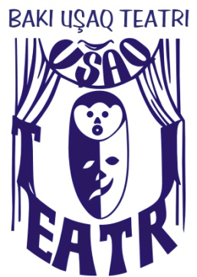
Baku Children Theatre
under the Ministry of Culture and Tourism of the Azerbaijan Republic

Address: 13 Mirgasimov St., Baku
Tel: (012) 441 46 54
Fax: (012) 449 43 65
E-mail: teatrbut@mail.ru

Dear Parents!
The children of 5 -8 ages who have artistic aptitude and tendency to theatre, as well as physically disabled children of 6 – 11 ages are invited to the studio of “Korpam”(My baby) Experimental Children Theatre working under the Baku Children Theatre.
The Chairman and director of the theatre is Intigam Soltan.
The Baku City Theatre was founded on 9 April, 2001 by direction № 260 passed by the Baku City Culture and Tourism Office. Since 1 May, 2002 Intigam Soltan has been charged with the organizational and activity works of the theatre. More than 35 highly-qualified and amazing tastes of the audience performances have been staged since 2002 up to date.
The theatre is an only professional children theatre in the Caucasus. It is an only theatre that its playbills display the age limit of the audience. The theatre has gained a great number of audience during its activity period and having participated at a number of republican events and international theatre festivals the theatre was awarded with diploma and honours. Together with the state and international organizations the theatre carried out successful projects. These organizations are International Red Cross Committee, Ministry of Justice, the Information of CoE in Azerbaijan, UN Office on Drugs and Crime in Baku. The theatre has always properly implemented the targeted activity and financial plans. The theatre enlarges its activity consecutively the performances were staged both in the capital city and in the regions of our country, as well as the theatre paid tour visits to abroad. About 70 children specialists work at the theatre.
The theatre studio comprised of children who need peculiar care was established under the Baku Children Theatre in November, 2009. The Official opening of the theatre took place on March with the performance “Pretty Fatma and her friends”. During its short activity period this studio participated successfully at both 4th national festival of integrative performances of disabled children and youth held in our country and 2nd international activities festival of youth who have lacks in their health held in Moscow.
Since 15 October, 2010 the Baku Children Theatre’s newspaper consisted of 16 pages of released once a month.

